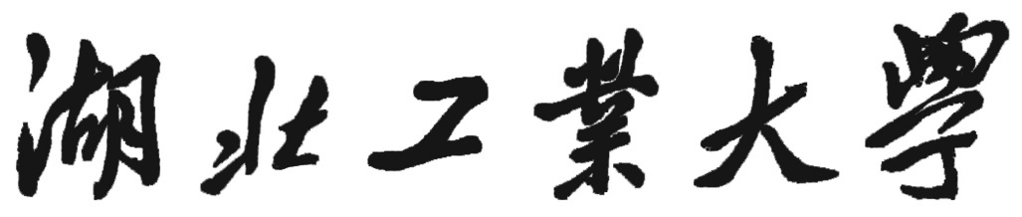
Hubei University of Technology

来华留学生博士学位开题审查与考核表
Review and Evaluation Form of Dissertation Proposal for
International Doctoral Candidates
姓 名: ____________________________________
Name: _______________________________________
学 号: ____________________________________
Student ID: ___________________________________
培养学院: ____________________________________
Training School: ______________________________
研究方向: ____________________________________
Research Direction: ____________________________
指导教师: ____________________________________
Supervisor: ___________________________________

填表时间： 年 月 日
Date:

- 个人信息
Personal information
姓名  Name |  | 性别  Gender |  | 学号  Student ID
国籍  Nationality |  | 护照号  Passport No. |  | 出生年月  Date of Birth
二、自我小结
Self-evaluation
（一）在校表现、实践能力、健康状况等
School performance, practical abilities, health statuses, etc.

（二）已修课程及成绩
Courses taken and scores
课程名称  Course Title |  | 学分  Credit | 成绩  Score | 课程名称  Course Title | 学分  Credit | 成绩  Score
总学分
Total credits

三、资格审查
Qualification Review
资格审查  Qualification | HSK | 通过等级  Level
考试成绩
Score
考试时间
HSK Test Date
 | 论文发表  Paper Publication | 论文题目  Paper Title
论文收录
Paper Collection
论文题目
Paper Title
论文收录
Paper Collection
论文题目
Paper Title
论文收录
Paper Collection
 |  | 导师意见  Opinion from Supervisor | 经审核以上论文发表符合来华留学博士研究生学位授予条件。  The above papers are approved to meet the requirements of doctoral degree awarding for international students.  导师签名： 年 月 日  Signature of Supervisor: Date
国际学院意见  Opinions from School of International Education | 学院主管领导签名： （学院公章）  Signature of School Head: (Official Seal)  年 月 日  Date
说明：
Note:
1、本表由学生填写，课程成绩由学生自行在系统中查询；
This form shall be filled in by the student and the course scores shall be checked in the system by the student;
2、HSK、论文等均由学生向国际学院教务办提供复印件1份。
The student shall submit one copy of HSK result and papers to Teaching Affair Office of SIE, HBUT.
四、开题情况
Dissertation Proposal
论文题目
Dissertation Title
选题来源
Source of Title
开题答辩时间  Date of Defence |  | 答辩小组意见（是否同意开题）  Comment from Judges (Agree or Disagree)
五、考核意见及结果
Evaluation Results
导师意见  Opinion from Supervisor | （对博士研究生的课程成绩、科研和实践能力、思想品德等方面进行综合评价）  (Comprehensive evaluation on course scores, research abilities, practical abilities, and moral characters of the doctoral candidate, etc.)  导师签名： 年 月 日  Signature of Supervisor: Date:
考核小组意见  Opinions of the Evaluation Group | 该生考核综合评定等级为  Level of the Student:  （考核结果分三个等级：优秀（＞80分）、合格（80～60分）、不合格（＜60分））  (Evaluation results are divided into three levels: excellent (>80 points), qualified (60-80 points), unqualified (<60 points))  组长签名： 年 月 日  Signature of Group Leader: Date:
培养学院意见  Opinions of Training School | 培养学院主管领导签名： （培养学院公章）  Signature of School Head: (Official Seal)  年 月 日  Date:

